The goal of the five-day mini-lesson is to give students the opportunity to use reading, writing, thinking, speaking, and listening to develop skills to read a text closely.
Close Reading Progression Guide
“Read like a detective. Write like a reporter.”
Susan Richmond
Sources: Fisher & Frey, CSAI, Beth Burke NBCT Permission to use when full citation is given.

Selecting the Text
Select a short text of a higher text complexity for your grade level. You may choose an excerpt of a longer text. Use the Text Lexile Measures by Grade along with the Text Complexity Rubrics attached to this document. Plus see attachment that gives directions on how to use the Lexile Analyzer.

Select a text that is worthy of a close read. When using informational text, connect the text that fits with the content standards.

The daily close reading mini-lesson should last 15 to 20 minutes each day except for day 5 for the writing activity.
Common Core State Standards

As you write and plan your five day close reading progression, refer CCSS to match each day with the standards.

Enhanced Balanced Literacy
The close reading progression includes the Shared Reading Experience.
If the close read progression occurs during the ELA block, this progression takes the place in the Reading Workshop. The Close Read is the mini-lesson prior to students reading independently. The five-day close read progression encompasses the shared reading experience.

Considerations

- Day 1 the student reads text independently without any support from the teacher. Do not provide any support with the first reading of the text. This is done purposefully; however, proficient readers activate schema before, during and after reading a text. It is an important that this comprehension strategy is taught and reinforced as the year progresses. The goal of the close read progression is to teach the learner to read a passage closely.
- A vocabulary task is always included. The teacher identifies specific words that students rereads the text to search for context clues that supports the meaning of the word or helps the student understand the word enough to make meaning from the text. Choose words that are central to know for the overall meaning of the text.

The overall goal is to teach students strategies to figure out meaning of a word when the meaning of the word gets in the way of comprehending the text. Prior mini-lessons may have been taught, but on this particular day, you may want to reinforce those strategies.

The teacher may reinforce these strategies by modeling and doing a think aloud while reading the text. Teach students how to use the tools accessible in the room such a dictionary and thesaurus (both print and digital) as a last resort.
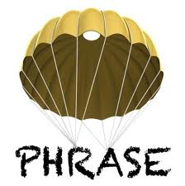
- A paraphrasing activity may occur. Ask students to independently write a paraphrase of one or more paragraphs.
- Include 2 to 4 text based questions. Use the reading CCSS, Blooms’ Critical Thinking Cue Questions, and/or DOK Question Stems.
- After the first day include opportunities for a shared reading experience (BCSD Enhanced Balanced Literacy).
- End the week with a writing task. (Writing Prompt)
- A discussion task is included for a minimum of four days. Students discuss with partners and whole class discussion.

Teacher Preparation:

- Read the text several times.
- Read with a questioning mind and take time to use an Internet search to find your answers and build your own background knowledge.
- Use the CCSS Reading standards and Blooms Critical Questioning Cues and DOK Question Stems to develop text based questions.

Be an Observer

Observe what students find successful or challenging. Listen to their conversations. Observe their reading habits. Use this information to plan further small group, 1:1 conference/instruction, or whole-class mini-lessons.

Teach Students the Protocol!
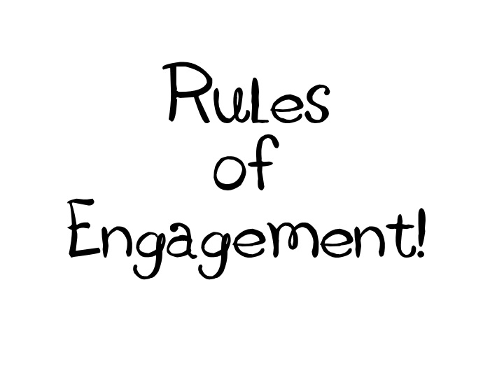
- Everyone reads!
- Everyone writes!
- Everyone will work with a learning buddy!
- Everyone will speak and participate in the conversation!
- Everyone listens when a person is speaking!
- When talking about the text, refer to the text!
- Everyone addresses each other respectfully!

*Consider designing a rubric to assess the protocol.

The Close Reading Progression

Day 1
- Students read independently and annotate on the text by underlining important details (phrases, sentences, or words) and circling confusing or difficult words.
*set a time (10 minutes?)

- When everyone is done, have student turn and talk with a learning buddy. Encourage students to discuss what the passage is about and talk about the important details they underlined.

- Teacher reads the passage aloud or gets a fluid reader to read the passage aloud.
*Consider doing number 3 first, then #2)

Extensions/Variations:
- Use the text to model a comprehension strategy. Have students practice the comprehension strategy as they read during independent reading.

Day 2
- Shared Reading Experience (part of the text or all of the text) - Have choral reading of the text.

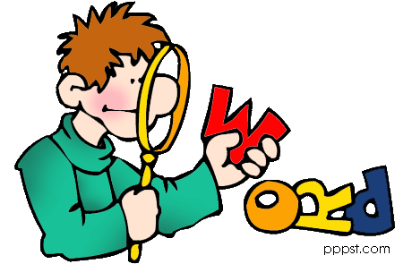
- Select 2-3 vocabulary words for the students to focus their attention. Have student identify context clues from the text and teach word problem solving. It is important to get students to underline and/or write the evidence on paper.

- Provide a discussion task centered on the vocabulary words. Have students share their evidence with their learning buddy and reach a consensus before sharing with the whole class. You may ask students to search for another word, a synonym, to replace the word in the text. If the student did this, how would it change the meaning of the text? How would it change the meaning the author wanted to convey?

Extensions/Variations:
- Have students create visual representations of the words individually, and then share with their learning buddy and whole class.

- Have students create context sentences using the words individually and then share with learning buddy and whole class.

- Design a mini-lesson to teach students what to do when they run across a word they either don’t know the meaning or even know how to pronounce the word. Have them practice this skill during independent reading.

- Add new words to word wall and encourage students to find these words in their reading, use words in their class discussions, and use the words in their writing when appropriate.

- Project part of the text on your Smart Board. Call students attention to the conventions and grammar skills you are teaching in writing workshop. For example, call students’ attention to punctuation, parts of speech and sentence, and other skills you are teaching. Ask what would happen to the meaning of the text if the author did not use punctuation?

- Conventions and Grammar (follow-up from above) - Have students find examples of the conventions or grammar skill you are teaching in your independently reading.

- Teach students to track words they are not familiar with as they read. Teach vocabulary learning strategies that good readers use.

Day 3
- Shared reading of the passage: choral read, echo read, or any combination (either part of the text or all of the text or then read independently the rest of the text). Divide students in groups, assign each group a different, allow them to rehearse, and then do a performance.

- Have students paraphrase a small portion of the text. Paraphrase paragraph 1. Increase the number of paragraphs paraphrasing up to 3 or 4. Give them apple practice. (You choose the paragraphs for them to paraphrase. Above is just an example)

- Allow enough time for students to write.
*If this is your first time asking students to paraphrase, you may want to model how to paraphrase with paragraph one, then paragraph two “we do it together,” and paragraph three “you do it by yourself.” You may have to repeat this cycle for the first two or so close reading activities.

- Turn and share with learning buddy (or small group). Students need practice speaking and listening to others.
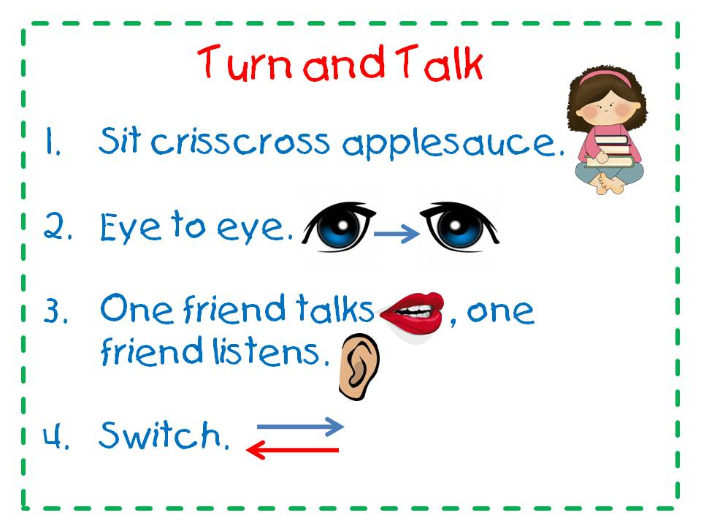
  - Have them collaborative agree or disagree how they paraphrased.
  - Have them explore how their paraphrases were alike or different.
    - How was your partner’s paraphrase like yours? Different?
    - After listening to each other, how would you revise your paraphrase?
    - Was there anything important left out? How do you know?

- Whole group- Teacher facilitates a discussion about what they heard from listening to each other:
  - How did you and your partner reach consensus?
  - Did you disagree?
  - Have some share paraphrases they may have revised?

Day 3 Extensions/Variations:
- Use the passage in a mini-lesson to teach comprehension strategies. For example, teach students how to monitor their comprehension. Then have them practice this strategy during the independent reading.

Day 4
- Start by a shared reading of the text like you did in day 2. If you divided into groups on day 3, have the same groups read today.

- The students read the text to answer 2 to 4 text-based questions. Students are encouraged to write the answers in complete sentences. If this is the first time your students are doing the progression, you may want to start with one question and model how to read to search for evidence in the text. I would not suggestion having more than 3 or 4.

- Allow time for students to work independently.

- Share with a learning buddy or small group. As students share their answers, listen to their conversations and challenge their thinking by asking pairs deeper questions.

- Lead a whole group discussion around the questions.

Extensions/Variations:
- After whole group discussions, have student revise their answers.
- Pair the text with a fictional text that you can use as an interactive read aloud. Have students track the different points of view, similarities and difference, what was real or fictional, etc.

Day 5
- Begin by Share Read Experience like day 4. Think about designing a different variation for the share reading of the text.

- Provide students with writing prompt. The prompt must require them to use evidence from the text. The prompt is designed that students write a minimum of a paragraph.

- Have students work with their learning buddy to revise and edit their essay.

- Use the provided rubric to assess the writing.

Lexile Text Measures by Grade
Grade | 2012 CCSS Text Measures*
1 | 190L to 530L
2 | 420L to 650L
3 | 520L to 820L
4 | 740L to 940L
5 | 830L to 1010L
6 | 925L to 1070L
7 | 970L to 1120L
8 | 1010L to 1185L
9 | 1050L to 1260L
10 | 1080L to 1335L
11 and 12 | 1185L to 1385L

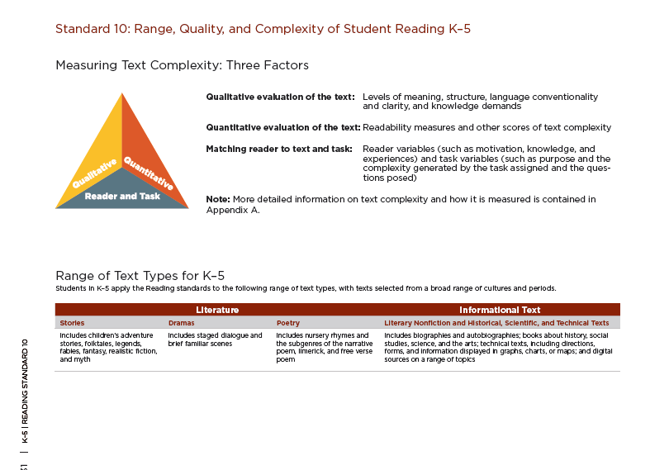
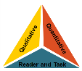
TEXT COMPLEXITY: QUALITATIVE MEASURES RUBRIC
INFORMATIONAL TEXTS

LEVELS OF PURPOSE

High

- Purpose: subtle, implied, difficult to determine

Middle High

- Purpose: implied, but fairly easy to infer

Middle Low

- Purpose: implied, but easy to identify based upon context or source

Low

- Purpose: explicitly stated

STRUCTURE

High

- Organization of Main Ideas and Details: highly complex; not explicit, must be inferred by the reader

- Text Features: if used, are essential in understanding content

- Use of Graphics: sophisticated graphics, essential to understanding the text, may also provide information not otherwise conveyed in the text
Middle High

- Organization of Main Ideas and Details: complex but largely explicit; may exhibit traits common to a specific subject or discipline
- Text Features: if used, greatly enhance the reader’s understanding of content
- Use of Graphics: some sophisticated graphics, may occasionally be essential to understanding the text

Middle Low

- Organization of Main Ideas and Details: may be complex, but clearly stated and generally sequential

- Text Features: if used, enhance the reader’s understanding of content

- Use of Graphics: largely simple graphics, supplementary to understanding of the text

Low

- Organization of Main Ideas and Details: clearly stated and sequential

- Text Features: if used, help the reader navigate and understand content but are not essential
- Use of Graphics: use of simple graphics, unnecessary to understand the text

LANGUAGE CONVENTIONALITY AND CLARITY

High

- Meaning: dense and complex; may be abstract, ironic, and/or figurative; language may be purposefully ambiguous or misleading
- Register: generally unfamiliar, archaic, subject-specific, or overly academic

Middle High

- Meaning: somewhat complex; may occasionally be abstract, ironic, and/or figurative

- Register: occasionally unfamiliar, archaic, subject-specific, or overly academic

Middle Low

- Meaning: largely explicit and easy to understand with few occasions of more complex meaning

- Register: largely contemporary, familiar, conversational; rarely unfamiliar, archaic, subject-specific, or overly academic
Low

- Meaning: explicit, literal, straight-forward, easy to understand

- Register: contemporary, familiar, conversation
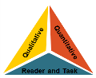
TEXT COMPLEXITY: QUALITATIVE MEASURES RUBRIC
LITERARY TEXTS

LEVELS OF MEANING

High

- Multiple Levels of Complex Meaning
Middle High

- Multiple Levels of Meaning

Middle Low

- Single Level of Complex Meaning

Low

- Single Level of Simple Meaning

STRUCTURE

High

- Narrative Structure: complex, implicit, and unconventional

- Narration: many shifts in point of view
- Order of Events: not in chronological order
- Use of Graphics: sophisticated graphics, essential to understanding the text, may also provide information not otherwise conveyed in the text
Middle High

- Narrative Structure: some complexities, more implicit than explicit, some unconventionality
- Narration: occasional shifts in point of view
- Order of Events: several major shifts in time, use of flashback
- Use of Graphics: some sophisticated graphics, may occasionally be essential to understanding the text

Middle Low

- Narrative Structure: largely simple structure, more explicit than implicit, largely conventional,
- Narration: few, if any, shifts in point of view
- Order of Events: occasional use of flashback, no major shifts in time
- Use of Graphics: largely simple graphics, supplementary to understanding of the text

Low

- Narrative Structure: simple, explicit, conventional, no shifts in point of view
- Narration: no shifts in point of view

- Order of Events: chronological

- Use of Graphics: use of simple graphics, unnecessary to understand the text

LANGUAGE CONVENTIONALITY AND CLARITY

High

- Meaning: implicit or inferred meaning, heavy use of figurative or ironic language, may be purposefully ambiguous or misleading at times
- Register: generally unfamiliar, archaic, domain-specific, or overly academic

Middle High

- Meaning: some implicit or inferred meaning, use of figurative or ironic language

- Register: occasionally unfamiliar, archaic, domain-specific, or overly academic

Middle Low

- Meaning: largely explicit and literal meaning, subtle use of figurative or ironic language

- Register: largely contemporary, familiar, conversational, rarely unfamiliar, archaic, domain-specific, or overly academic
Low

- Meaning: explicit and literal meaning, little or no use of figurative or ironic language

- Register: contemporary, familiar, conversational

KNOWLEDE DEMAND

